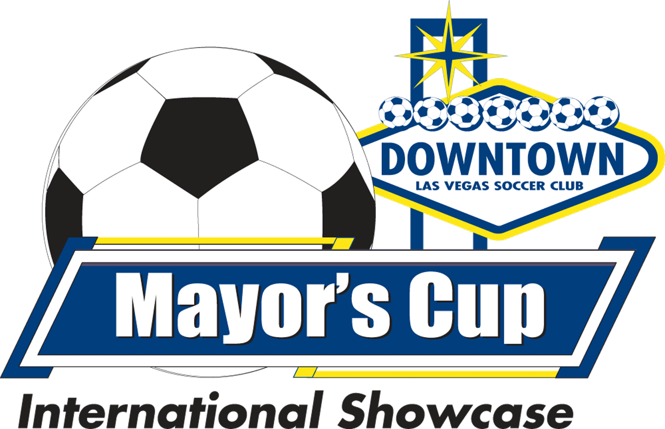

LAS VEGAS MAYOR’S CUP
May 7-9, 2021 and May 14-16, 2021
Letter of Attestation

Please type or print clearly

Team Name_______________________ Boys/Girls Year___________________

This team has appointed: ___________________________________________ as it’s designated Safety Officer. The person listed here is a club employee, officer, coach or team manager of the team listed above. More information about the Safety Officer duties can be found at lvmayorscup.com/covid19.

I attest that each member of my team’s parents have received the COVID-19 Protocols and have agreed to abide by the guidelines listed.

I attest that our team will have a hand sanitizer with at least 60% alcohol content at the team bench area for anyone on my team to use.

I attest to the fact that this coach has been tested for COVID19, and the results of that test have been uploaded into the documents section of the team account at Gotsoccer.com

Coach Name__________________ Date of Test _________ Result___________
Must be after 4/16/2021

I attest to the fact that this team manager has been tested for COVID19, and the results of that test have been uploaded into the documents section of the team account at Gotsoccer.com

Manager Name__________________ Date of Test _________ Result___________
Must be after 4/16/2021

I attest to the fact that this team official has been tested for COVID19, and the results of that test have been uploaded into the documents section of the team account at Gotsoccer.com

Official Name__________________ Date of Test _________ Result___________
Must be after 4/16/2021

For additional Coaches, managers or team officials, use an additional sheet.

___________________________________________________ _______________________________________
Team Safety Officer (Print Name) Signature and Date

